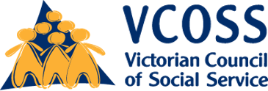
February 2020
VCOSS submission to the Victorian Public Engagement Framework Consultation Draft

Introduction
VCOSS welcomes the opportunity to provide feedback on the Public Engagement Framework Consultation Draft (the draft framework). VCOSS is the peak body for social and community services in Victoria. VCOSS supports the community services industry, represents the interests of Victorians facing disadvantage and vulnerability in policy debates, and advocates to develop a sustainable, fair and equitable society.
VCOSS applauds the Victorian Government’s commitment to meaningful, principled and inclusive engagement with communities. Meaningful engagement, where there is genuine openness to hearing and including different views and perspectives, leads to better decision making and program design, and more engaged communities.
Effective engagement and co-design requires building a shared understanding of how communities will work with government to inform policy or decision-making processes, how timely feedback will be provided, and ultimately to demonstrate how the information provided by the community contributed to the final outcome.
Effective government policy reduces inequities and provides the greatest benefit to those who need it most. To do this successfully, governments must hear the voices of diverse groups, and understand how they experience policy and services differently. Lived experience must be not only heard, but valued.

Focus on co-design
Recommendations
- Include co-design with communities as an engagement principle in the Framework
- Work with communities to design engagement processes
While VCOSS generally supports the vision and outcomes of the draft framework, it would be strengthened by including a clear understanding of the principles of co-designing with vulnerable communities. Co-design involves more than just consultation. Co-design means coming alongside people who experience vulnerabilities, to work with them in creating interventions, services and programs that work in the context of their lives and reflect their values and goals. This involves letting go of professional assumptions about a group’s perspectives and experiences and actively learning from what people say and do.
Co-design values, prioritises and incorporates multiple forms of expertise, including but extending beyond more traditional and limited reliance on professional knowledge and research. It uses these to consider different ways of approaching social problems with specific groups.
In co-design, the methodology will vary in the same way that people, problems and organisations do. Co-design practice is more a way of thinking than a process. This is because people, problems and contexts are always going to vary; as will the organisations and practitioners who work with them. At its core, co-design involves transferring and sharing power with people who are affected by social problems. By working together, more effective solutions can be discovered by exploring innovative and creative alternatives.
Unfortunately VCOSS members and stakeholders report that engagement processes are sometimes poorly designed and do not place the experiences and perspectives of communities at the centre. We commonly hear examples where Government:
- Does not clearly articulate the purpose of the engagement or identify where people can influence decisions.
- Adopts a starting point that stakeholders disagree with or is misunderstood
- Asks the wrong questions or makes incorrect assumptions about communities or needs
- Is overly formal, bureaucratic or confusing
- Fails to identify and therefore engage the right stakeholders and impacted communities.
While some of these risks are identified in the draft framework, many would be addressed by a stronger focus on co-designing the engagement process itself with communities.
For example, the Victorian Auditor-General’s Office (VAGO) often ‘pre-consults’ with relevant stakeholders to make sure they are asking the right questions in broader engagement processes. This gives organisations and those with expert, on-the-ground knowledge the opportunity to shape the consultation process and ensures VAGO has the right stakeholders engaged.

Engage proactively with marginalised groups
Recommendations
- Require proactive and targeted engagement strategies for reaching specific communities and cohorts
- Recognise community service organisations and Aboriginal community-controlled organisations as partners in engaging communities
- Highlight examples of good practice in co-designing with communities
The importance of proactively engaging vulnerable communities and people is not adequately captured in the draft framework. Communities are best placed to identify their own needs, and how government decisions, policy-making and service design will impact them.
The framework should not assume that marginalised groups, who often have histories of trauma or past negative experiences with systems and policies, will engage, even where decisions will directly impact on their lives. People might experience stigma around identifying (for example as having a mental illness or being part of the LGBTIQ+ community), fear of speaking up, and mistrust of government and support services.
The framework should emphasise the need for specific strategies to reach communities including Aboriginal and Torres Strait Islanders, refugee and asylum seekers, people with disability and LGBTIQ+ people. Younger people, older people, single parents, rural and regional Victorians, people who are homeless or living with a mental illness may also need targeted consultation strategies.
There are many examples of excellent practice. For example, in 2015 the Office for Youth commissioned community organisations like Melbourne City Mission to consult diverse cohorts of young people. The consultation report highlighted the depth of insight young people had into their personal circumstances and those of their peers. It also highlighted their awareness of personal and system barriers, and their knowledge of solutions.
As one young person said: “Younger people know what they want for their generation.”
Partnering with community organisations is one way to reach cohorts and communities that are ‘hard to reach.’ Community organisations have developed positions of trust and legitimacy in their communities, by building positive long-term relationships with people over years, or even generations. Employing peer workers and people with lived experience of disadvantage means community organisations often create a safer environment for vulnerable people to engage, because they feel their experiences are validated and understood.
The draft framework should recognise the role of community organisations as a way to engage ‘hard to reach’ communities.
In the Aboriginal community, Aboriginal community-controlled organisations (ACCOs) hold positions of trust and legitimacy. The governance, structure and mission of ACCOs means they are embedded in their communities and connected with people in ways distinct from government and other mainstream services. This ‘on-the-ground’ knowledge, experience and connection means ACCOs are well placed to identify complex social problems and develop innovative solutions to addressing disadvantage. ACCOs must be acknowledged in the Engagement Framework as partners in co-design and vital links to community.
For many people, speaking to others who share and understand their lived experience can also build faster, stronger connections for people to feel comfortable sharing their story. The framework is an opportunity to highlight peer support models of engagement, including employing local community leaders, facilitators with lived experience or provision of peer support counselling.
The approach used to develop the Victorian Disability Services Commissioner’s ‘Building Safe and Respectful Cultures’ pilot project in June 2019 provides some valuable learnings about engaging people with lived experiences. The project explored building safe and respectful cultures, particularly around people with disability who have experienced violence, abuse and neglect in services.
Community researchers with lived experience were employed to collect data and stories from people with disability, and it was noted that the relational nature of their role helped to build a sense of safety for participants; assisted with recognising subtle signs of discomfort, concern or feeling unsafe; and enabled staff to act and provide appropriate support.
These kinds of examples could be highlighted in the framework to encourage good practice.

Provide more information about accessibility
recommendation
Refer to existing materials about accessible communications
Partner with community organisations to reach people in welcoming and supportive environments
Consider the range of barriers that can prevent people engaging, including physical location, unwelcoming environments, digital exclusion or anxiety
VCOSS supports the strong focus in the draft framework on accessibility, including physical accessibility of buildings, provision of information in alternative formats and plain English, and thinking about supports including interpreters, travel expenses and inclusion training.
We also welcome the focus on “going to where people are.”
For example, the Djirra runs Sisters Day Out workshops to prevent family violence by facilitating community networks, reducing social isolation, raising awareness of family violence and providing information and tools to promote community safety. The workshops are an opportunity for Djirra and other invited organisations to engage Aboriginal women in a relaxed, supportive and culturally safe environment. Government can consider approaching organisations like Djirra that convene community events, to discuss whether it is appropriate to engage participants in consultation and co-design.
However, the draft strategy could go further in providing practical information about engaging with all Victorians. Some people have chronic illnesses, allergies or anxieties that make attending and participating in events difficult. Accessibility is not limited to physical venue and materials. A significant number of Victorians have low levels of literacy. Many also do not have access to the internet at home. Online engagement mechanisms or notification of consultations may not effectively engage these groups.
The Victorian Government already provides guidance about accessible communications and documents. In VCOSS’ experience not all staff know about or are familiar with these guidelines. The framework should refer directly to them.
Additional guidance about the meaning of physical accessibility should also be incorporated. For example, VCOSS’ website contains information about how to get to our office, width of doorways, lighting and accessible and gender neutral bathrooms. This helps people prepare to attend events and consultations.
We also recommend the Victorian Parliament website, where you can undertake a virtual/online tour of meeting rooms, including information about floor plans, width of doorways and aisles.

Resource communities to engage and pay people for their time
REcommendations
Encourage payment for people and organisations for their time participating and preparing for government processes
Hearing the voices of marginalised groups and people is crucial to good policy and decision-making. Hearing the voices of people with lived experience of disadvantage, or who have been let-down by the service system, helps us understand the causes of disadvantage, the barriers to seeking help and the challenges in navigating complex systems.
In a report on co-designing social initiatives with people experiencing vulnerabilities, VCOSS said “finding the right way to approach social problems involves partnering with the people who face them head on.”
Organisations that are governed by people with relevant lived experience, like LGBTIQ groups, Aboriginal community-controlled organisations and consumer-led services help make sure policy reforms and service design are generally suited to people’s needs.
However, this can place a heavy burden on people and organisations. While most are committed to improving outcomes for their communities, participation requires resources. It often involves significant preparation, research and consultation with peers and members. It can also place a heavy personal burden, requiring people to retell often traumatic stories about their own experiences with the system.
People should not experience financial barriers to participation in government processes, and their participation should not encumber them with a financial burden. People’s time and expertise should be valued, and paid for.
For example, during the consultation phase of the Royal Commission into Family Violence and in the implementation of its recommendations, consumer organisations report being called on to participate in countless consultations and service design processes. Many organisations received no or little additional funding to undertake this work, and had to fit it in around supporting clients and community.
There is reference in the draft framework to “additional support… including travel expenses or accommodation”. But this doesn’t adequately represent the cost of engaging in consultation processes. The framework should value people’s expertise and encourage payment for people with lived experience participating in engagement processes.

Include target timeframes
Recommendations
Be specific about best-practice timeframes for consultation processes: at least 6-8 weeks’ notice should be provided for in-person consultations and submissions
Meaningful engagement requires sufficient time. Time for people to become aware of the process, undertake their own research, consultation and thinking, and prepare their responses accordingly.
A minimum of 6-8 weeks should be provided for the preparation of written submissions. Similar notice should be provided for in-person consultations.
In VCOSS experience, four weeks is simply insufficient time for meaningful consultation. We often scramble to prepare responses to draft regulations or decisions within this timeframe. As a result, we may miss out on hearing valuable stories or voices from within our own membership or stakeholders.
VCOSS strongly recommends timeframes be expressly referenced in the framework.

Align consultation processes
Recommendations
Recognise the burden on communities and organisations of multiple engagement processes underway at once
Where possible, recommend aligning or combining engagement processes
There can be scores of public consultation processes underway at the same time. Often community service workers are trying to provide input to multiple consultations across different departments, parliamentary inquiries and royal commissions, while still managing their ongoing workloads and (in some cases) delivery of frontline services.
This should be recognised in the framework.
Government should make sure they research other consultation processes underway at the same time, and are aware of the impacts this is likely to have on communities and organisations. They might need to allow more time for submissions or schedule additional consultation events. There may also be opportunities to combine engagement processes with similar or related content, to minimise the burden on communities.
The Engage Victoria website is an example of a coordinated process, where information is collated in one central spot. This could be built on through more coordination of consultations across departments.
Community organisations are providing vital community support to vulnerable community members. They have invaluable information about community need and how policies work ‘on the ground’. But participation in consultation processes can take them away from frontline service delivery. Community organisations often report frustrations when they have to provide staff or consultants with basic background about their work, the environment they operate in or reforms and policies that apply to them.
Engagement processes should respect the work of community organisations, by making sure staff have undertaken basic background research, and have knowledge about the sector and the work they do. They should also build on past engagement processes and be clear about how information from other processes, including submissions and consultation reports will be used and incorporated into current processes.

For more information, or to discuss this submission further, please contact:
Brooke McKail, Manager Policy and Research
03 92351018 or brooke.mckail@vcoss.org.au

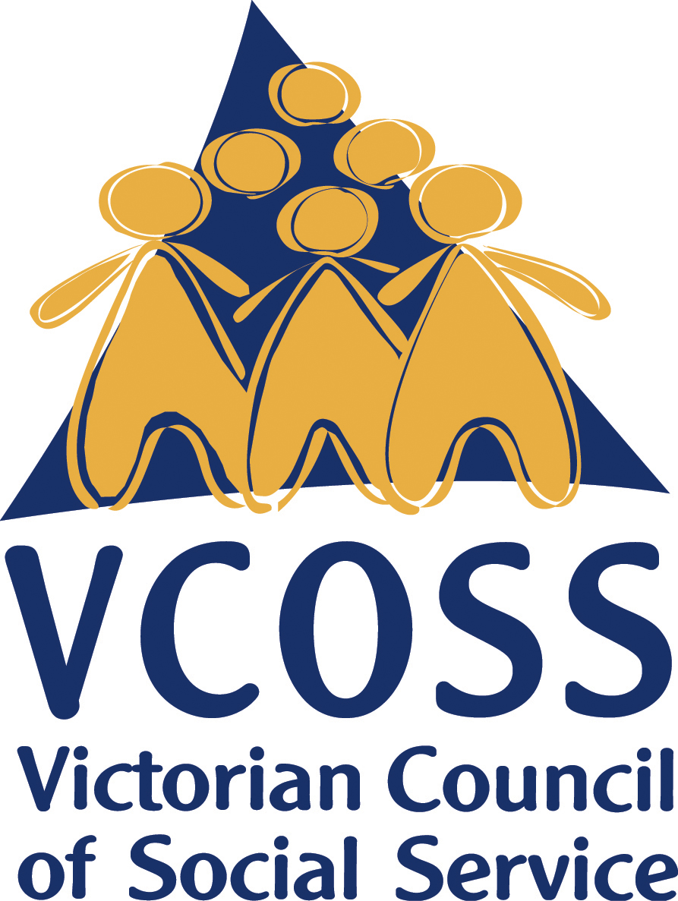

/vcoss
@vcoss
ChannelVCOSS
vcoss.org.au

VCOSS, Walk alongside: Co-designing social initiatives with people experiencing vulnerabilities, 2015.
Ibid.
Melbourne City Mission, What’s important to YOUth: Final report from Melbourne City Mission Youth Consultation,
https://www.odsc.vic.gov.au/abuse-prevention/building-safe-and-respectful-cultures/
https://captur3d.io/view/parliament-of-victoria/parliament-of-victoria-federation-room?m=e1UJGQMVJdW
VCOSS, Walk alongside: Co-designing social initiatives with people experiencing vulnerabilities, 2015.

