JULY 2020
VCOSS submission to the ESC’s draft decision on supporting energy customers through the coronavirus pandemic

Improving access to financial relief one part of a system-wide response
VCOSS welcomes the opportunity to provide feedback on the Essential Services Commission’s (ESC’s) draft decision on supporting energy customers through the coronavirus pandemic.
The pandemic is a compounding health, social and economic crisis. As well as the risk of the virus itself, COVID-19 has also driven an increase in unemployment, with more people facing poverty and financial hardship.
To support low-income Victorians through this crisis, regulatory changes must be accompanied by a combination of targeted financial support and the ongoing delivery of accessible and effective consumer information.

To play its part in this system-wide response, the ESC must continue to work collaboratively with retailers, community service organisations and government agencies. Ongoing work is necessary to ensure energy consumer protections are well-understood and genuinely accessible to all Victorians (for example, promoted in plain terms and languages other than English, through multiple channels and different formats).
We do not yet know the full scale of hardship and unemployment as a result of COVID-19. But for Victorians facing financial hardship and rising energy costs,
a prompt response is necessary.
The proposed residential customer changes in this draft decision will improve access to financial relief. They will also ensure that more Victorian households who have sought a payment plan are in-fact on their current retailer’s best offer.

Offer URGs application over the phone by default
VCOSS supports the ESC’s proposal to require retailers to offer support to residential customers by completing an online utility relief grant application form over the telephone on their behalf, where possible and if the customer consents. This should be an ongoing requirement.
The utility relief grant grants scheme, or URGS, helps Victorians to pay for their mains electricity, gas or water bills (up to a fixed cap over a two-year period) when they are unable to pay due to a temporary financial crisis. The URGS payment is a last-resort option, when retail market guidance, targeted concessions and payment plan safety nets are insufficient.
Under current Energy Retail Code requirements and parallel arrangements with the Department of Health and Human Services (DHHS), retailers have an existing obligation to provide specific advice about any government and non-government assistance and are paid a fee by DHHS for each application form they generate.
All application processes require some “back-end” development and training support. VCOSS recognises that formalising this better practice may require some quick work by retailers and DHHS to refine business and IT systems. That pre-work is critical, as we must avoid creating a backlog of applications (as occurred after the implementation of online forms).
The cost and effort involved in making such refinements is not overly burdensome, and providing this support is already current practice for some water companies. Importantly, this additional assistance makes a big difference for the person experiencing a temporary financial crisis.

Reduce risk of future household debts by extending tariff check requirement
Energy is an essential service that should, at all times, be accessible, affordable and equitable.
VCOSS supports the proposal to extend the requirement on retailers to conduct a tariff check for all residential customers receiving tailored assistance, not just those who cannot afford the ongoing cost of their energy.
There is never a good time – and certainly not during a pandemic – to be paying extra (effectively, a "loyalty tax") on your essential services bills.
Indeed, there is a strong argument that retailers should at-least offer to conduct a tariff check whenever a customer has reached the point of calling their energy retailer, whether for standard assistance (i.e. they anticipate payment difficulty) or where they are only requesting a bill deferral.
The regulatory regime should facilitate and encourage such help-seeking behavior, given widely-recognised social and psychological barriers to it (especially for people with limited English language skills, or experiencing mental health challenges or financial distress).
The ESC is proposing that this requirement apply for only six months, pending a broader review of the payment difficulty framework. However, the impacts of the COVID-19 pandemic will continue for the foreseeable future. We suggest the extended tariff check requirement be introduced now and kept in place until the review of the payment framework.

Monitor the implications of small business assistance and network cost waivers
VCOSS notes that the ESC’s proposed draft decisions on creating minimum entitlements to payment flexibility and related assistance for small businesses is likely to also to be relevant to retail-focused social enterprises.
VCOSS does not have any specific feedback on the operation of the network relief packages in Victoria, under which retailers are able to access waivers or deferrals of network charges for eligible residential customers in financial stress.
In principle, however, we encourage the ESC to be watchful in ensuring that any arrangements between distributors and retailers do not risk creating future debt cliffs for consumers experiencing payment difficulties.
Similarly, the ESC needs to be mindful of any flow-on costs from new small business entitlements and network charge arrangements that affect the ongoing affordability of this essential service (while noting that any assertion of such potential costs will need to be robustly justified).

Prioritise prevention of financial hardship
In our response to the ESC’s then draft decision on the payment difficulty framework, VCOSS noted the current framework “is premised on customer engagement with retailers, which creates disconnection [and earlier/other financial] risks for people who cannot engage for reasons beyond their control, including language barriers, family violence, major health problems, and chaotic living circumstances.”
The COVID-19 pandemic has left many Victorians struggling with anxiety, financial stress, remote schooling and an array of other challenges. Some will be dreading September, with the possible reduction in income support or JobSeeker. Engaging with energy retailers may not be their top priority.
The community sector is a vital partner for the ESC, helping to bridge the gap between Victorians who need assistance and the support available to them.
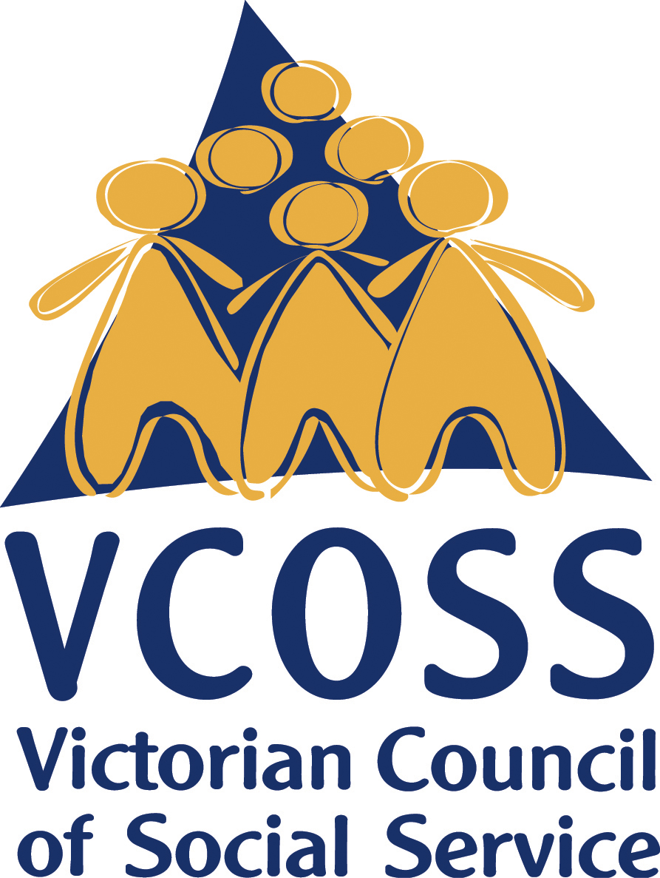
For retailers, now is the time to be doing more, not less. The Energy Retail Code (and indeed other legal obligations) are at any time simply the minimum standards for these businesses. While acknowledging the financial pressures at this time, we would hope that retailers recognise the current crisis as an opportunity to more proactively prevent energy bills mounting-up. If there are regulatory barriers preventing better practice in this regard, then we encourage retailers to raise them with the ESC for examination.
/vcoss
@vcoss
ChannelVCOSS
vcoss.org.au

For example, retailers could be examining their own customer data to identify any high-tariff customers and/or concession-holders who are on quarterly billing cycles and whose electricity usage is increasingly during the coronavirus lockdown. Appropriate proactive contact, including outbound calls, could then be made to offer monthly billing instead.
VCOSS will continue to monitor responses to the evolving coronavirus pandemic and welcomes ongoing ESC engagement.
---

---
To discuss this submission further, please contact Jarrod Lenne, Energy Policy Advisor on jarrod.lenne@vcoss.org.au

