NOVEMBER 2020
VCOSS response to the Second Review
of the Premises Standards 2010

Overview
VCOSS welcomes the opportunity to participate in the discovery phase of the second review of the Disability (Access to Premises – Building) Standards 2010 (the Premises Standards). Accessible premises, places and spaces open doors to a range of social and economic opportunities for people with disability and older people. Accessibility enables inclusion, dignity and independence in daily life, provides equitable choices and options, and supports health, wellbeing and community connectedness.
In Victoria, under state-based legislation and the Premises Standards, it is unlawful for public places to be inaccessible for people with disability, however, many places remain fully or partly inaccessible. Consultation for the next National Disability Strategy found more than 40 per cent of survey respondents believe accessibility in the community has not changed, or has become worse, over the past five years. Poor accessibility also impacts older people, people experiencing temporary mobility restrictions due to illness or injury, and parents or carers using prams, and can limit their participation, independence and choices in the community.
The 2016 review of the Premises Standards identified a range of recommendations, including the need to improve connections between built environment standards, increase understanding and awareness of the Premises Standards across different stakeholder groups, and strengthen governance and data collection. While the Australian Government accepted or noted many recommendations in its response to the 2016 review, it is unclear what has been actioned and achieved since this time.
The second review should have a strong focus on the accountability and impact of the Standards, and should meaningfully engage people with disability, older people, families, carers and advocates to ensure key issues and barriers to building accessible, inclusive and age-friendly cities and communities are addressed.

Listening to and learning from lived experience
Engaging people with disability, older people, their families and carers, and advocates early on in the review process will ensure the review focuses on the experiences, insights and priorities of people with lived experience. People with disability, older people and their allies need to have trust and confidence in the power and scope of the Premises Standards to drive change, remove access barriers and eliminate discrimination.
The scoping survey, which seeks to hear diverse range of voices and perspectives, is a welcome starting point for the second review. We recommend the Department of Industry, Science, Energy and Resources builds upon this approach to comprehensively, and meaningfully, assess the impact and effectiveness of the Standards.
The second review should:
- Widely promote consultation stages
- Provide fair, equitable and accessible opportunities for people with disability, older people, families, carers and advocates to participate in all aspects of the review process
- Engage people with disability in all expert advisory panels or committees related to the review
- Give stakeholders confidence that the review will drive meaningful improvements, including increased compliance with the Standards.

The review is commencing in a time of immense change, challenges and complexity across the community and the policy and government landscape. The COVID-19 pandemic has been disruptive, difficult, and devastating for all Australians, and has particularly impacted people with disability, older people, families and carers, advocates and community organisations.
During the pandemic, several significant government inquiries and consultation processes have continued, including the disability and aged care Royal Commissions, the development of the next National Disability Strategy and state-based plans, and reviews of other DDA-related standards. The regulatory impact statement (RIS) on the proposal to include minimum accessibility standards for housing in the National Construction Code (NCC) was also recently released for comment.
The stress, anxiety and additional pressures of the pandemic – particularly for Victorians who experienced sustained lockdown measures – is likely to have prevented many people and organisations from sharing their lived experiences and expertise through these inquiries and processes. Wherever practical and possible, the Premises Standards review should seek to coordinate and collaborate with existing government review and inquiry processes to reduce duplication, mitigate consultation fatigue and ensure the insights people have shared in other forums is valued and elevated.
Key areas of focus
The review should seek to assess the impact and effectiveness of the Premises Standards in driving change and increasing access and inclusion across Australia.
Compliance with and enforcement of the Premises Standards, like other Standards under the Disability Discrimination Act 1992 (DDA), relies on people with disability and their allies knowing about, and advocating for, their rights. Under current arrangements, people with disability must lodge a formal complaint about inaccessible places and spaces for any remedial action to be considered. Complaints can be addressed to a range of parties, and while resolution can occur on an individual level, these complaints usually do not feed into or effect systemic change.
The Premises Standards are dense, technical, and likely to be inaccessible for many people with disability and the wider community. This presents a barrier to understanding, and in turn, impacts people’s capacity to make a complaint.

Since the last review of the Premises Standards, the Australian Human Rights Commission received on average just under 80 premises-related complaints each year. Considering 4.4 million Australians live with disability, it can safely be assumed the current compliance measures are not well known, effective or fair.
People with disability can also make complaints about public premises directly to builders, local council, state, territory and federal governments, however it is not clear who is ultimately responsible for hearing complaints, monitoring systemic issues and ensuring appropriate action is taken.
To ensure the second review contributes to action and change, the review should:
- Examine and report on progress towards the recommendations identified in the 2016 review, particularly in relation to
  - awareness and understanding
  - measurement and reporting,
  - compliance and accountability

- Consider the fairness and effectiveness of current compliance and complaints measures, and recommend options to increase and strengthen measures

- Assess the social, health and economic benefits of universal design and improving access to public spaces for all Australians

- Identify areas of good practice, as well as settings and environments that do not meet the Premises Standards or community expectations
- Explore whether improving or expanding the Premises Standards, or implementing other approaches, would be likely to achieve positive outcomes

- Identify opportunities to harmonise relevant Standards and legislation to improve coverage, awareness and compliance.
Additionally, the review process should embed scope for responsiveness to the findings and recommendations of:
- the Royal Commission into Violence, Abuse, Neglect and Exploitation of People with Disability
- the Royal Commission into Aged Care Quality and Safety
- the next National Disability Strategy
- consultation regarding the proposal to include minimum accessibility standards for housing in the National Construction Code (NCC).

__________________________________
This submission was prepared by Rhiannon Wapling and authorised by VCOSS CEO Emma King.
For enquiries please contact Deborah Fewster at deborah.fewster@vcoss.org.au
A fully accessible version is available online at vcoss.org.au/policy

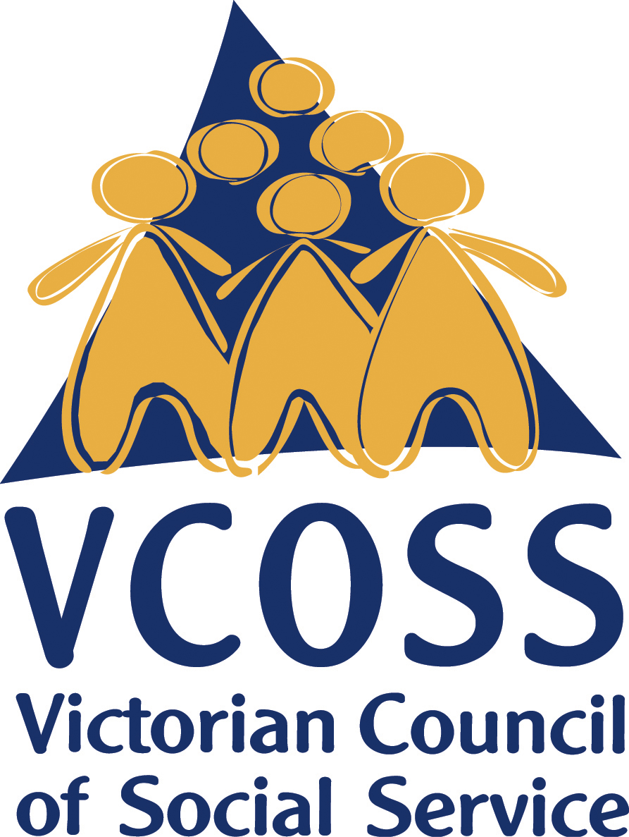

/vcoss
@vcoss
ChannelVCOSS
vcoss.org.au

Department of Social Services, Consultation report - to help shape the next National Disability Strategy (beyond 2020), December 2019.
AHRC, Complaint Statistics, 2019-20, 2018-19, 2017-18, 2016-17, accessed 12 November 2020.

